**LAB-6**

***1: Student Marks Analyzer***

***Write a Java program to accept marks of 5 students using an array.***

***The program should display:Total marks, Average marks, Highest mark, Lowest mark***

import java.util.Scanner;

class StudentMarksAnalyzer {

    public static void main(String[] args) {

        Scanner scanner = new Scanner(System.in);

        int[] marks = new int[5];

        // Input marks

        System.out.println("Enter marks for 5 students:");

        for (int i = 0; i < marks.length; i++) {

            System.out.print("Student " + (i + 1) + ": ");

            marks[i] = scanner.nextInt();

        }

        int total = 0;

        int highest = marks[0];

        int lowest = marks[0];

        // Calculate total, highest and lowest

        for (int mark : marks) {

            total += mark;

            if (mark > highest) {

                highest = mark;

            }

            if (mark < lowest) {

                lowest = mark;

            }

        }

        double average = (double) total / marks.length;

        // Display results

        System.out.println("\n Student Marks Summary ");

        System.out.println("Total Marks   : " + total);

        System.out.println("Average Marks : " + average);

        System.out.println("Highest Mark  : " + highest);

        System.out.println("Lowest Mark   : " + lowest);

    }

}

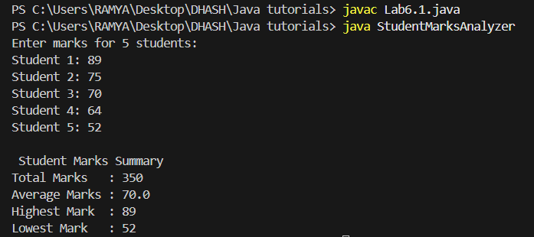

***2: Frequency Counter in Array***

***Write a Java program to accept 10 integers into an array (with possible duplicates). Display how many times each unique number appears in the array.***

import java.util.Scanner;

class FrequencyCounter {

    public static void main(String[] args) {

        Scanner scanner = new Scanner(System.in);

        int[] numbers = new int[10];

        boolean[] visited = new boolean[10]; // to track counted elements

        // Input 10 integers

        System.out.println("Enter 10 integers:");

        for (int i = 0; i < numbers.length; i++) {

            System.out.print("Number " + (i + 1) + ": ");

            numbers[i] = scanner.nextInt();

        }

        // Count frequencies using nested loop

        System.out.println("\n--- Frequency of Numbers ---");

        for (int i = 0; i < numbers.length; i++) {

            if (visited[i]) {

                continue; // Skip already counted numbers

            }

            int count = 1;

            for (int j = i + 1; j < numbers.length; j++) {

                if (numbers[i] == numbers[j]) {

                    count++;

                    visited[j] = true; // Mark as counted

                }

            }

            System.out.println("Number " + numbers[i] + " appears " + count + " time(s)");

        }

    }

}

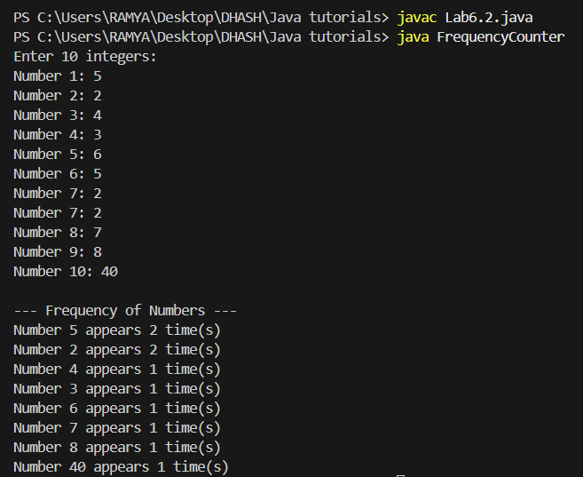

***3: Array Sorting and Reverse Display Write a Java program that: Accepts an array of N integers from the user Sorts the array in ascending order***

import java.util.Scanner;

import java.util.Arrays;

class ArraySortingAndReverse {

public static void main(String[] args) {

Scanner scanner = new Scanner(System.in);

// Input array size

System.out.print("Enter the number of elements (N): ");

int n = scanner.nextInt();

int[] arr = new int[n];

// Input array elements

System.out.println("Enter " + n + " integers:");

for (int i = 0; i < n; i++) {

System.out.print("Element " + (i + 1) + ": ");

arr[i] = scanner.nextInt();

}

// Sort the array in ascending order

Arrays.sort(arr);

// Display sorted array

System.out.println("\nSorted Array (Ascending):");

for (int num : arr) {

System.out.print(num + " ");

}

// Display reverse of the sorted array (Descending)

System.out.println("\n\nSorted Array (Descending):");

for (int i = n - 1; i >= 0; i--) {

System.out.print(arr[i] + " ");

}

}

}

